**Political Donations Analysis**

Student’s Name

Institutional Affiliation

Course Number and Name

Instructor Name

Due Date

1. **Donation Types and Payment Methods**

Cash donations emerged as the predominant form of financial support for political parties, capturing the lion's share of contributions. The total value of cash donations amounted to an impressive £838,901,120. This substantial sum represented a commanding 77.06% of the entire pool of contributions. In essence, cash was the lifeblood of political financing, accounting for the vast majority of financial support extended to the parties (McEwen et al., 2012).

Public funds, while not surpassing cash donations, secured the second position among donation types. The cumulative value of public funds contributions reached £161,606,553. These funds, which likely emanate from various public financing mechanisms, constituted a noteworthy 14.85% of the total contributions. Although substantial, this figure was noticeably less than the contribution from cash donations, illustrating the difference in scale between these two sources of funding.

In stark contrast, the category known as "Unidentified donor" emerged as the least common donation type. Contributions falling under this category amounted to a mere £49,450. When expressed as a percentage of the total donations, it was evident that "Unidentified donor" donations made up an infinitesimal portion, approaching 0%. These nominal contributions underscored their minimal impact within the broader context of political party financing.

1. **Total Donation Trends Over Time**

The analysis of donation trends over time reveals significant patterns in political contributions. The data series began in 2001 with an initial contribution of £35,407,928. However, the following year, in 2002, there was a notable downtrend, with contributions dropping to £23,864,683. From 2002 to 2010, a clear uptrend was observed in donation amounts. This period marked a consistent increase in contributions, culminating in 2010 with a substantial donation of £73,368,548, signifying a peak in political funding.

Subsequently, a downtrend emerged from 2010 to 2012, with donations decreasing to £41,865,222. However, this decline was followed by another significant uptrend from 2012 to 2016. During this period, the highest donation amount was recorded at £88,900,771 in 2016, indicating a period of robust financial support. In contrast, a drastic drop in contributions was observed between 2016 and 2019. By 2019, the total donation had decreased to £30,298,774, marking a noteworthy decline in political funding.

1. **Donor Status Analysis**

Individual Donors: Individual donors emerged as the most significant contributor in terms of donor status, making substantial contributions totaling £459,309,389. This represented a substantial share of approximately 42.19% of the total contributions, signifying the substantial role played by individuals in funding political parties.

Trade Unions: The second-highest donor status was attributed to Trade Unions, with a notable total donation of £192,590,324. This contribution constituted approximately 17.69% of the total contributions, underlining the significance of Trade Unions as a source of financial support.

Companies: Companies also played a substantial role in political financing, contributing a total of £188,070,522. This represented a considerable portion of around 17.28% of the total contributions, emphasizing the financial involvement of corporate entities.

Registered Political Parties: Among the various donor status categories, Registered Political Parties emerged as the least significant contributor. Their total donation amounted to £3,150,706, equivalent to approximately 0.29% of the total contributions.

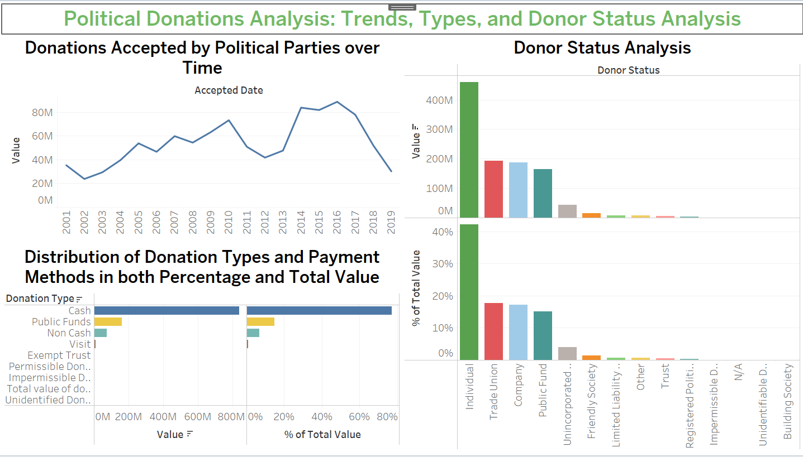

1. **Top Donors**

The analysis of the top donors reveals the significant financial supporters of political parties. GMB emerged as the leading donor, providing a substantial contribution of £26,308,947, followed closely by UNISON with a notable donation of £21,663,176. The Communication Workers Union (CWU) claimed the third position among donors, contributing £19,433,897. The Co-operative Party secured the fourth spot with a contribution of £13,404,374, while the House of Commons itself made a substantial contribution of £13,276,329, ranking fifth. Unite the Union took the sixth position with a total donation of £11,284,900, followed by another branch of the Communication Workers Union (CWU) as the seventh-highest donor, with £8,802,413. The Union of Shop Distributive and Allied Workers rounded out the top 8 donors with a notable contribution of £5,970,865. These donors played significant roles in supporting political causes through their substantial financial contributions.

1. **Map**

The utilization of postcodes in the visualization successfully portrayed the geographic distribution of donors across the entirety of Great Britain. This approach allowed for a comprehensive and visual understanding of the geographic locations where donors are situated, providing valuable insights into the spatial aspects of political contributions (Webber & Burrows, 2018).

1. **Histogram of Total Donation**

The first bin, labeled as "OK," had the highest frequency or count of values, with 63,039 instances. This suggests that the majority of donors made contributions of less than £1,000, indicating a prevalent pattern of relatively modest donations.

The second bin, labeled as "110K," had a count of 607. This bin indicates that a significant number of donors made contributions in the range of approximately £1,000 to £110,000.

The last bin, labeled as "220K," had a count of 414. This bin represents donors who made contributions in the range of approximately £110,000 to £220,000.

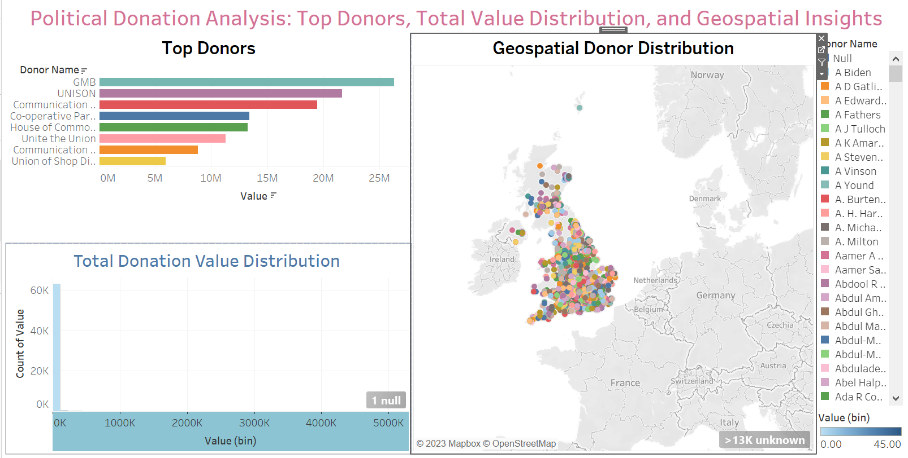

**Conclusion**

In conclusion, the analysis of the provided dataset on political party donations in Great Britain and Northern Ireland, achieved through six key objectives in Tableau, has revealed compelling insights. Cash donations emerged as the dominant funding source, representing 77.06% of total contributions, with a substantial value of £838,901,120. Temporal trends demonstrated fluctuations in political funding, with notable peaks in 2010 and 2016. Donor status analysis highlighted the pivotal role of individual donors (42.19%) and the substantial contributions from Trade Unions (17.69%) and Companies (17.28%). Top donors, led by GMB and UNISON, played significant roles, while geospatial analysis showcased the widespread distribution of donors across Great Britain. Finally, a histogram illustrated the prevalence of relatively modest donations, underpinning the multifaceted nature of political party financing in the region.

Top of Form

**References**

McEwen, N., Swenden, W., & Bolleyer, N. (2012). Introduction: Political opposition in a multi-level context. *The British Journal of Politics and International Relations*, *14*(2), 187-197.

Webber, R., & Burrows, R. (2018). *The predictive postcode: the geodemographic classification of British society*. Sage.